CHAPTER FOUR

SYSTEM ANALYSIS AND DESIGN

System analysis is the process of studying an existing or proposed system to understand how it works, identify its weaknesses, and determine what improvements are necessary. In the context of the EyeCare Management System, the system analysis phase involved a careful examination of the current manual and fragmented processes used in eye care clinics to manage patient information, clinical documentation, appointments, prescriptions, and billing. By thoroughly investigating these operational challenges, it became possible to define the functional and technical requirements needed to build an effective digital solution.
The analysis revealed that many eye care clinics currently operate without a unified information system. Patient registration, appointment management, clinical examinations, pharmacy dispensing, optical sales, and billing are typically handled through separate tools such as paper registers, spreadsheets, or disconnected software applications. This fragmented approach creates significant barriers to efficient information flow, accurate data management, and coordinated patient care.
A key finding of the analysis was that data entered at one stage of patient care is rarely accessible in other departments without manual transfer. For instance, a prescription written by a doctor during a clinical examination may need to be physically carried to the pharmacy rather than being digitally routed. Similarly, billing staff may not have immediate access to a complete list of services rendered to a patient across departments, leading to potential revenue loss and administrative errors.
The system analysis also identified challenges related to data duplication and inconsistency. When patient information is maintained in multiple registers or files, it becomes difficult to ensure that all records are synchronized and up-to-date. Healthcare staff may work from outdated information, which can negatively affect clinical decision-making and patient care quality. Furthermore, the absence of role-based access control in manual systems means that sensitive clinical and financial records are not always adequately protected.
Based on these findings, the system analysis concluded that the EyeCare Management System must provide a centralized, integrated platform that eliminates the inefficiencies of the current fragmented approach. The proposed system must support seamless data flow between departments, ensure data accuracy and consistency, and provide secure access to clinical and administrative information for authorized users only.

4.2 Existing Approaches
Before the development of the EyeCare Management System, eye care clinics relied on a combination of manual processes and partially digitized tools to manage their operations. Understanding these existing approaches provides important context for the design of the proposed system and helps clarify why a fully integrated digital solution is necessary.

4.2.1 Paper-Based Record Systems
The most widely used approach in many clinics involves maintaining patient records in physical folders and registers. Patient registration details, examination findings, prescriptions, and appointment information are recorded by hand and stored in filing cabinets or shelves. While this approach is simple and does not require technological infrastructure, it introduces several significant challenges. Handwritten records are difficult to search and retrieve, particularly when a clinic serves hundreds or thousands of patients. Physical files are vulnerable to damage, loss, or unauthorized access, and maintaining data consistency across multiple departments using paper-based systems is extremely challenging.

4.2.2 Standalone Spreadsheet Applications
Some clinics have adopted the use of spreadsheet applications such as Microsoft Excel or Google Sheets to manage specific aspects of clinic operations, such as appointment scheduling or billing records. These tools offer improvements over purely paper-based systems by providing basic digital storage and calculation capabilities. However, standalone spreadsheets are not designed for multi-user access in real time, lack relational database structures needed for complex clinical data, and do not support role-based access control. Data entered in one spreadsheet is not automatically available in another, which means that the fragmentation problem is not fully resolved.

4.2.3 General-Purpose Practice Management Software
A small number of healthcare facilities use general-purpose practice management or hospital information system software that was not specifically designed for ophthalmology. These systems may provide modules for appointment scheduling and basic billing but typically lack specialized features required for eye care, such as visual acuity recording, intraocular pressure tracking, refraction data management, and optical inventory control. As a result, clinics using these systems often need to supplement them with additional tools, which reintroduces fragmentation.

4.2.4 Summary of Existing Approach Limitations
The table below summarizes the key limitations observed in the existing approaches used in eye care clinics:
Existing Approach | Key Features | Identified Limitations
Paper-Based Records | Simple, no technology needed | Data loss risk, difficult retrieval, no multi-department sharing
Spreadsheet Tools | Basic digital storage, calculations | No relational structure, no real-time multi-user access, fragmented data
General HMS Software | Appointment and billing modules | No ophthalmic specialization, missing clinical modules, not integrated
Manual Prescription Handling | Handwritten doctor prescriptions | Risk of misreading, no real-time pharmacy notification
Table 4.1: Summary of Existing Approaches and Their Limitations
4.3 The Proposed System
The proposed EyeCare Management System is a comprehensive, web-based platform specifically designed to address the operational challenges identified in the system analysis and to overcome the limitations of the existing approaches reviewed above. The system integrates all major clinical and administrative functions of an eye care clinic within a single, centralized digital platform, enabling seamless data flow between departments and providing authorized users with real-time access to accurate and up-to-date information.
At its core, the proposed system replaces fragmented manual processes with a structured electronic workflow. When a patient arrives at the clinic, their information is registered through the system's patient registration module. This information is immediately accessible to clinical staff in the triage room, where preliminary examination data such as visual acuity and initial intraocular pressure readings are recorded. The clinical findings are then instantly available to the consulting ophthalmologist, who can complete the full examination, record diagnosis and treatment plans, and generate prescriptions through the system's examination and prescription modules.
The proposed system also integrates pharmacy and optical shop management directly with the clinical workflow. Prescriptions generated by the doctor are automatically routed to the pharmacist through the system, eliminating the need for physical document transfer. Similarly, refraction data recorded during examination is automatically available to the optical shop module when processing spectacle orders. All services provided are linked to the unified billing module, which consolidates charges from consultations, medications, optical products, and surgeries to generate a complete and accurate invoice for each patient.
The system is designed to support multi-branch clinic operations, allowing a clinic group with several physical locations to manage all branches through a single platform while maintaining strict data isolation between branches. Role-based access control ensures that each user type can only access and modify the information relevant to their specific role within the clinic.
The following diagram illustrates the high-level structure of the proposed system and how its major modules interact:
4.4 Requirements
The system requirements were derived from the findings of the system analysis phase, the review of existing approaches, and the specific operational needs of eye care clinics. Requirements are divided into two categories: functional requirements, which describe the specific operations the system must perform, and non-functional requirements, which define the quality and performance standards the system must meet.

4.4.1 Functional Requirements
Functional requirements describe the specific features and behaviors that the EyeCare Management System must provide in order to support clinical and administrative operations effectively. The following functional requirements have been identified:

User Authentication and Authorization
The system shall provide a secure login mechanism for all users. Each user shall be assigned a specific role, such as Administrator, Doctor, Receptionist, Pharmacist, or Optician, and the system shall enforce role-based access control to ensure that each user can only access the modules and data relevant to their assigned role.
Patient Registration and Records Management
The system shall allow receptionists to register new patients by recording their personal details including name, date of birth, contact information, and identification number. The system shall maintain a complete and searchable medical history for each patient, including previous visits, diagnoses, treatments, and prescriptions.

Appointment Scheduling and Management
The system shall provide a module for scheduling patient appointments with specific doctors on selected dates and times. The module shall display appointment status such as Scheduled, Completed, or Cancelled, and shall allow authorized staff to reschedule or cancel existing appointments as required.
Triage and Preliminary Examination Recording
The system shall provide a module for recording preliminary clinical measurements taken during triage, including visual acuity (VA) for both eyes, pinhole test results, and initial intraocular pressure (IOP) readings. These measurements shall be automatically linked to the patient's record and made available to the consulting doctor.
Clinical Examination and Diagnosis
The system shall provide a comprehensive clinical examination module for ophthalmologists and optometrists. The module shall include structured fields for recording refractive error data such as sphere (SPH), cylinder (CYL), and axis values for both eyes. It shall also support recording of clinical diagnosis, management plans, and follow-up schedules.
Prescription Management
The system shall allow doctors to generate digital prescriptions for medications and optical products based on clinical examination results. Prescriptions for medications shall be automatically routed to the pharmacy module, and optical prescriptions shall be linked to the optical shop module for processing spectacle orders.
Surgery Scheduling and Management
The system shall provide a module for scheduling and documenting eye surgeries. The module shall record the type of surgery, scheduled date and time, the operating doctor, pre-operative and post-operative notes, and the surgical outcome.
Pharmacy Inventory and Dispensing
The system shall maintain a complete inventory of pharmaceutical products including eye drops, medications, and surgical supplies. The module shall track stock levels in real time, support dispensing of medications against doctor prescriptions, and trigger automated alerts when stock falls below a defined reorder level.

Optical Inventory and Sales
The system shall manage the inventory of optical products including frames by brand and model, lens types, and accessories. It shall support the processing of spectacle orders linked to patient refraction data and manage optical sales transactions.

Billing and Payment Management
The system shall automatically consolidate charges from all clinical and retail services provided to a patient, including consultations, surgeries, medications, and optical products, to generate a single, itemized invoice. The system shall support multiple payment statuses including Paid, Unpaid, and Partial Payment, and shall produce official payment receipts upon confirmation of payment.

Reporting and Analytics
The system shall provide management reports including daily revenue summaries, outstanding patient balances, inventory usage reports, appointment statistics, and branch performance comparisons. Reports shall be filterable by date range, branch, and service category.

Multi-Branch Management
The system shall support the management of multiple clinic branches from a single administrative dashboard. Each branch shall maintain separate staff assignments, patient records, inventory, and financial records. A superadmin role shall have visibility across all branches.

The following table provides a consolidated summary of the functional requirements:
FR ID | Module | Description | User Role
FR-01 | Authentication | Secure login and role-based access | All Users
FR-02 | Patient Records | Register patients and manage medical history | Receptionist, Doctor
FR-03 | Appointments | Schedule, reschedule, and cancel appointments | Receptionist
FR-04 | Triage | Record VA, pinhole, and IOP readings | Triage Nurse
FR-05 | Clinical Exam | Record refraction, diagnosis, and management plan | Doctor
FR-06 | Prescriptions | Generate digital prescriptions for pharmacy and optical | Doctor
FR-07 | Surgery | Schedule surgeries and record surgical outcomes | Doctor, Admin
FR-08 | Pharmacy | Manage drug inventory and dispense medications | Pharmacist
FR-09 | Optical Shop | Manage frame/lens inventory and spectacle orders | Optician
FR-10 | Billing | Generate invoices and manage payments | Billing Staff
FR-11 | Reporting | Generate financial and operational reports | Admin, Manager
FR-12 | Multi-Branch | Manage multiple clinic locations from one dashboard | Superadmin
Table 4.2: Summary of Functional Requirements

4.4.2 Non-Functional Requirements
Non-functional requirements define the quality attributes and performance standards that the EyeCare Management System must satisfy in order to be reliable, secure, and usable in a clinical environment. The following non-functional requirements have been identified:

Performance

The system shall respond to standard user requests such as patient lookup, appointment booking, and record retrieval within three seconds under normal operating conditions. The system shall be capable of supporting at least fifty concurrent users across multiple branches without significant degradation in response time.

Security
The system shall implement industry-standard security measures to protect sensitive medical and financial data. This includes encrypted password storage using hashing algorithms, HTTPS encryption for all data transmitted between the client and server, and session-based authentication to prevent unauthorized access. Role-based access control shall ensure that users can only access data and functions permitted by their assigned role.

Reliability and Availability
The system shall maintain an availability of at least 99% during clinic operating hours. The database shall be designed with appropriate backup mechanisms to ensure that patient data can be recovered in the event of system failure. Critical data entry forms shall include input validation to prevent incorrect or incomplete data from being stored.

Usability
The system interface shall be designed to be intuitive and easy to use for healthcare professionals with basic digital literacy. The user interface shall be consistent across all modules, providing clear navigation menus, readable typography, and logical workflow progression that matches the natural patient journey through the clinic.

Scalability
The system architecture shall be designed to accommodate growth in the number of users, patients, branches, and data volume without requiring significant changes to the core system. The PostgreSQL database and Node.js backend shall be capable of scaling horizontally as the clinic network expands.

Maintainability
The system codebase shall be organized in a modular and well-documented manner to facilitate future maintenance, feature additions, and bug fixes. The use of TypeScript, Prisma ORM, and standardized API conventions shall support long-term maintainability by ensuring consistent data types and structure throughout the application.

Compatibility
The system shall be accessible through modern web browsers including Google Chrome, Microsoft Edge, Mozilla Firefox, and Safari, without requiring the installation of additional software on client devices. The interface shall be responsive and functional on desktop computers, laptops, and tablet devices.
4.5 Feasibility Study
A feasibility study is an assessment conducted to determine whether a proposed system can be successfully developed and deployed given the available resources, technical capabilities, time constraints, and financial considerations. The feasibility study for the EyeCare Management System was conducted across three dimensions: technical feasibility, economic feasibility, and schedule feasibility.

4.5.1 Technical Feasibility
Technical feasibility refers to whether the required technology and skills are available to develop and operate the system. The EyeCare Management System is technically feasible because it uses modern and widely supported technologies such as Next.js, Node.js, Express.js, PostgreSQL, and Prisma. These tools are reliable, open-source, and commonly used in web development. In addition, the development team has the necessary technical knowledge to build and maintain the system. The system also requires only a standard web server and can be accessed through web browsers, making it easy to deploy and use.

4.5.2 Economic Feasibility
Economic feasibility evaluates whether the system is cost-effective and beneficial. The EyeCare Management System is economically feasible because it is developed using open-source technologies, which eliminates software licensing costs. The main costs are related to development time and hosting services. The system helps reduce administrative work, improves billing accuracy, and enhances inventory management, which leads to cost savings. Therefore, the benefits of the system outweigh the costs, making it a financially viable solution.

4.5.3 Schedule Feasibility
Schedule feasibility evaluates whether the proposed system can be developed, tested, and delivered within the available timeframe. The EyeCare Management System was planned for development within the period from February 2026 to June 2026, providing approximately five months for the completion of all development phases.
The project timeline was structured using an iterative and incremental development model, allowing each major module to be developed and validated before proceeding to the next. This approach helped ensure that the project remained on schedule by breaking the development process into manageable phases and providing regular checkpoints for evaluating progress.
The following table presents the project schedule showing the estimated duration for each development phase:

No. | Development Phase | Duration | Target Period
1 | Requirement Analysis and Planning | 2 weeks | February 2026
2 | System Design (Architecture, DFD, ERD) | 2 weeks | Late February 2026
3 | Database Design and Setup | 1 week | Early March 2026
4 | Core Module Development (Auth, Patients, Appointments) | 3 weeks | March 2026
5 | Clinical Modules (Triage, Exam, Prescriptions, Surgery) | 3 weeks | Late March – April 2026
6 | Pharmacy, Optical, and Billing Modules | 3 weeks | April 2026
7 | Reporting, Multi-Branch and Admin Features | 2 weeks | Early May 2026
8 | System Testing and Bug Fixing | 2 weeks | May 2026
9 | Documentation and Final Submission | 2 weeks | June 2026
Table 4.3: Project Development Schedule

The schedule was considered achievable given the scope of the project and the iterative development methodology adopted. Regular progress reviews throughout the development period ensured that any delays in individual modules could be identified and addressed before affecting the overall project timeline. Based on this assessment, the schedule feasibility of the proposed system is confirmed.

4.5.3 Schedule Feasibility
Operational feasibility evaluates whether the proposed system will function effectively within the organization and be accepted by its users. The EyeCare Management System is operationally feasible because it is designed to be user-friendly and easy to use for clinic staff such as administrators, receptionists, doctors, and pharmacists. The system supports daily operations including patient registration, appointment scheduling, examination recording, billing, and inventory management, which aligns with existing workflows in eye care clinics. In addition, minimal training is required for users due to the simple and intuitive interface. By improving data management, reducing manual work, and enhancing coordination between departments, the system is expected to be widely accepted and effectively used in the organization
4.5.3 System Design
System design translates the requirements identified during the analysis phase into a detailed technical blueprint that guides the development of the EyeCare Management System. This section presents the key design models used to represent the system's structure, behavior, and data flows, including Data Flow , Use Case Diagrams, and (ER Diagram).

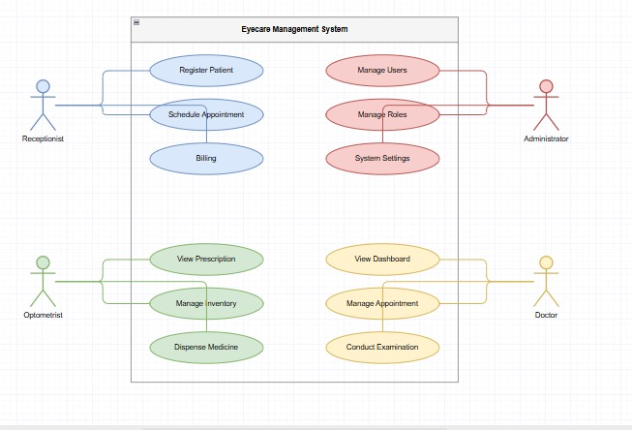

4.5.4 Use Case Diagram
The Use Case Diagram identifies the different actors who interact with the EyeCare Management System and describes the primary use cases, or functional activities, associated with each actor. The main actors in the system are the Superadmin, Administrator, Doctor, Receptionist, Pharmacist, and Optician.
The following table describes the primary use cases associated with each actor:

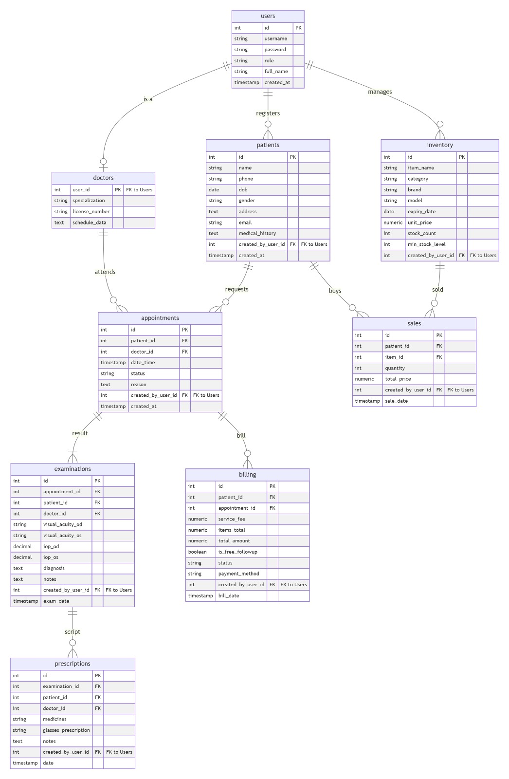
ERD Diagram
Entity Relationship Diagram (ERD) of the EyeCare Management System The Entity Relationship Diagram (ERD) illustrates the database structure of the EyeCare Management System and shows the relationships between major entities such as Patients, Users, Appointments, Clinical Examinations, Prescriptions, Billing, Pharmacy, and Optical Management. The diagram provides a visual representation of how data is organized and interconnected within the system to ensure efficient data management and integrity.

Database Design
The database design defines the structure of the PostgreSQL relational database used to store all data managed by the EyeCare Management System. The database is designed based on the entity-relationship model described in the previous section and implemented using Prisma ORM, which provides schema definition, migration management, and type-safe database access.
The database adopts a normalized relational structure to minimize data redundancy and ensure data integrity. Foreign key constraints are used to enforce referential integrity between related tables, ensuring that records cannot be orphaned or linked to non-existent parent records. Each table uses an auto-generated UUID as its primary key to ensure globally unique record identification across branches.
The following table describes the major database tables, their primary attributes, and their relationships:

Table Name | Key Attributes | Relationships
Branch | id, name, address, phone, isActive | Has many Users, Patients, Inventory items
User | id, name, email, passwordHash, role, branchId | Belongs to Branch; handles Appointments as Doctor
Patient | id, fullName, dateOfBirth, gender, phone, branchId | Belongs to Branch; has many Appointments, Exams, Bills
Appointment | id, patientId, doctorId, date, time, status, branchId | Belongs to Patient and User (Doctor)
TriageRecord | id, patientId, vaRight, vaLeft, iopRight, iopLeft, recordedAt | Belongs to Patient and Appointment
ClinicalExam | id, patientId, appointmentId, sphRight, cylRight, axisRight, sphLeft, cylLeft, axisLeft, diagnosis, plan | Belongs to Patient and Appointment; has Prescriptions
Prescription | id, examId, patientId, type (pharmacy/optical), notes | Belongs to ClinicalExam; has many PrescriptionItems
PrescriptionItem | id, prescriptionId, itemId, itemType, dosage, quantity | Belongs to Prescription; links to PharmacyItem or Frame
Surgery | id, patientId, doctorId, surgeryType, scheduledDate, status, outcome | Belongs to Patient; linked to Bill
PharmacyItem | id, name, category, stock, reorderLevel, unitPrice, branchId | Belongs to Branch; referenced in PrescriptionItems
OpticalFrame | id, brand, model, color, stock, price, branchId | Belongs to Branch; referenced in OpticalOrders
Bill | id, patientId, totalAmount, paidAmount, status, createdAt | Belongs to Patient; has many BillItems and Payments
BillItem | id, billId, description, serviceType, amount | Belongs to Bill; references Appointment, Surgery, or Item
Payment | id, billId, amount, paymentMethod, paidAt | Belongs to Bill; tracks individual payment transactions
Table 4.5: Database Tables, Attributes, and Relationships
The database design prioritizes data normalization, referential integrity, and query efficiency. Indexes are applied to frequently queried columns such as patient name, appointment date, and branch ID to improve system performance. The multi-branch architecture is enforced at the database level by including a branchId foreign key in all branch-specific tables, ensuring that queries are always scoped to the appropriate clinic location.
4.8 System Architecture Diagram
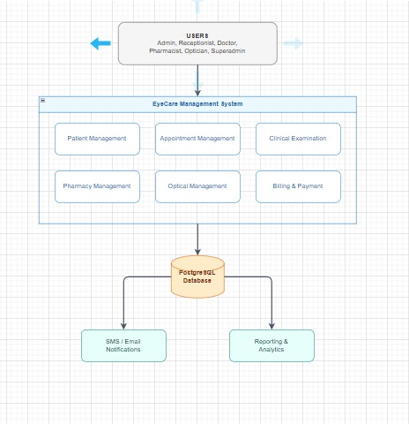
Figure 4.8: System Architecture Diagram of the EyeCare Management System
The System Architecture Diagram illustrates the overall structure of the EyeCare Management System and the interaction between its major components. Users such as administrators, receptionists, doctors, pharmacists, and opticians access the system through a centralized web application. The system manages patient records, clinical services, billing, and other operational activities, while all information is stored securely in a PostgreSQL database. The architecture also supports notification and reporting services to enhance communication, decision-making, and overall clinic efficiency.

4.6 Chapter Summary
This chapter presented the system analysis and design of the proposed EyeCare Management System. The analysis of existing eye care clinic operations revealed several challenges, including fragmented data management, manual record keeping, limited information sharing between departments, data duplication, and security concerns. Existing approaches such as paper-based records, spreadsheet applications, and general-purpose healthcare systems were reviewed, and their limitations were identified.
Based on these findings, a centralized and integrated web-based EyeCare Management System was proposed to streamline clinical and administrative processes within eye care clinics. The chapter outlined the system’s functional requirements, including patient registration, appointment management, clinical examinations, prescription handling, surgery management, pharmacy and optical inventory management, billing, reporting, and multi-branch administration. In addition, non-functional requirements such as performance, security, reliability, usability, scalability, maintainability, and compatibility were defined to ensure the system operates efficiently and securely.
The chapter also evaluated the feasibility of the proposed system from technical, economic, schedule, and operational perspectives, confirming that the project is practical, cost-effective, achievable within the planned timeframe, and suitable for adoption by healthcare personnel. Furthermore, the system design models, including the Use Case Diagram, ERD, and database design, were presented to provide a detailed blueprint for system implementation.
Overall, the analysis and design activities established a strong foundation for the development of the EyeCare Management System and provided a clear framework for implementing an integrated solution that improves patient care, operational efficiency, and information management in eye care clinics.

